**COVID 19 Worldwide Impact 2021**

**student name: Hang Lu**

**ID: 32985320**

**FIT 3179 studio 20**

**Words number:592**

URL:

**2.Domain, why and who**

The data visualization in this domain is COVID 19 Worldwide Impact. It aims to provide information on the spread of the virus in different regions and countries, as well as on the lethality

This visualisation is designed to help people understand how COVID-19 will be infected worldwide in 2021, along with the correlation between vaccination rates and viral lethality. The visualisations provide a clearer picture of the spread, trends and impact of the epidemic, as well as the protective effect of the vaccine against the virus.

**3.What: A brief description of the data (sources, authors, relevance, creation process, etc.).**

SOURCE URL: <https://www.kaggle.com/datasets/abhimaneukj/covid19-dataset>

AUTHOR : BIO

License: [CC0: Public Domain](https://creativecommons.org/publicdomain/zero/1.0/" \t "/Users/luhang/Documents\\x/_blank)

A new coronavirus, named 2019-nCoV, has been discovered for the first time in Wuhan, the capital of China's Hubei province

People develop pneumonia without a clear cause, and existing vaccines or treatments are ineffective.

There is evidence that the virus can be transmitted from person to person

Transmission rate (infection rate)

1. **Why and How**

**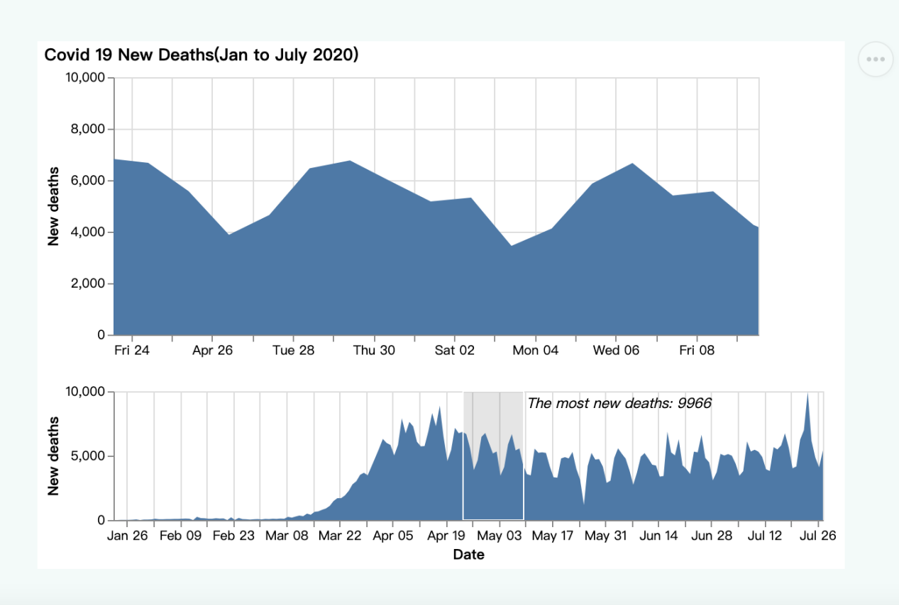**

Figure 1. Interactive area chart linked representing the relationship between

date and New case per day .The graph below reflects the daily additions of COIVD 19 patients from January to July, while the graph above zooms in on the selected portion to more clearly show the trend of daily additions.

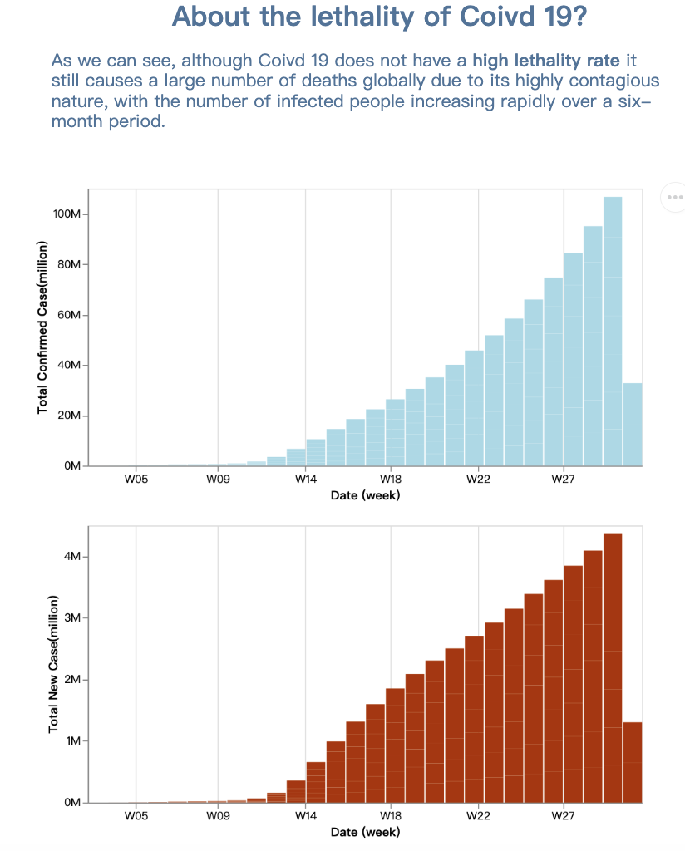 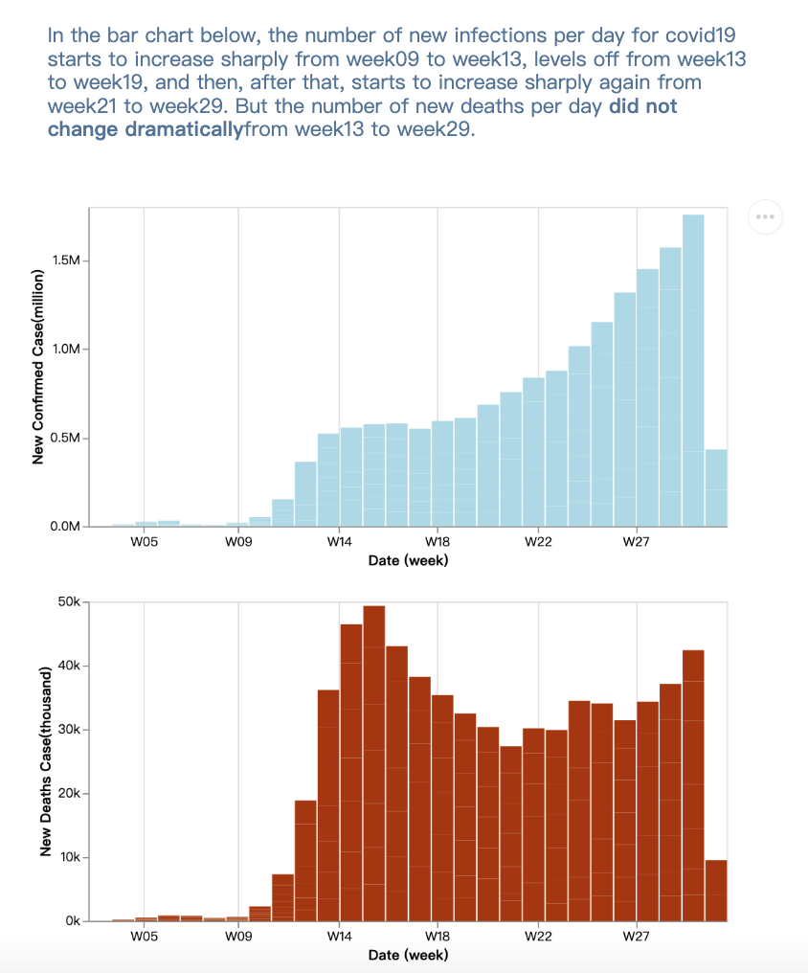

Figure 2 and Figure 3.

Different bar chart linked representing the relationship between

New cases and New deaths per day. We can notice a clear seasonal variation in patients with new infections on a daily basis. At the same time, although the overall number of new infections per day is gradually increasing, the number of new deaths per day does not have the same trend, and even shows a decreasing trend.

Figure 3. entire visualization

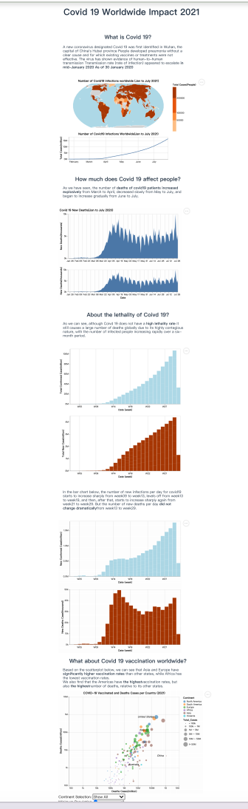

**5.Design**

1.Layout

Overall, all the text of the chart is for the centre of the page, which is the center of the layout. For each graph, most of the y-axis shows the number of infections or deaths, and the x-axis shows the time or number of vaccinations.

2.Colour

Firstly, I avoided using both red and green to make the data visualisation more friendly to the colour-blind community.  
Secondly, in the charts, I chose more distinguishable colours for different categories, which helps readers to distinguish between the different categories  
For data such as the number of infections or the number of deaths, I chose to use red in order to highlight the importance of this type of data.

3. Figure-ground

We create visual hierarchies by using variations of multiple visual elements. elements such as increasing font size, using bold text and introducing contrasting colours. Contrasting colours are used to highlight key data trends or relevance.

This design approach helps users identify and focus on important information more easily.

1. Typography

To improve the readability of the data visualisation, we chose to use sans-serif fonts for all elements, including body text, headings and annotations.

A consistent choice of font style, size, weight and colour helps to consistently emphasise key information.

1. Storytelling:

In terms of storytelling, the data visualisations are located in the centre of the page, in line with the natural reading pattern of top-to-bottom, left-to-right. This style of visualisation is similar to a magazine, with descriptive titles and text next to each chart.

For some keywords or important information, we will use bold to make it more eye-catching.

1. **Bibliography/list of references**

**Our World in Data:**

**url: [ourworldindata.org/coronavirus-source-data](https://ourworldindata.org/coronavirus-source-data" \t "/Users/luhang/Documents\\x/_new)**

**World Health Organization (WHO):**

**url: [www.who.int](https://www.who.int/" \t "/Users/luhang/Documents\\x/_new)**

**7.**

**

